IW Express API Documentation V 2.6

**Environment - Development**

**Table** **of Contents**

API #1: Consignment Creation 3

API #2: Shipping Label 4

API #3: Consignment Creation with Shipping Label 6

API #4: Consignment Tracking 9

Client Status Update Webhook 10

**API #1: Consignment Creation**

API URL: <https://dev-b2b.iwexpress.com:5001/iwexpress/iwe-integration-service/softdata/upload>

Request Type: POST

Input Authorization: Basic $2a$10$qWHNeBhu4FCGoJfuv2XVbO9Yq4QBUwGSvNM0bGpYUVc3iY8jXsJwO

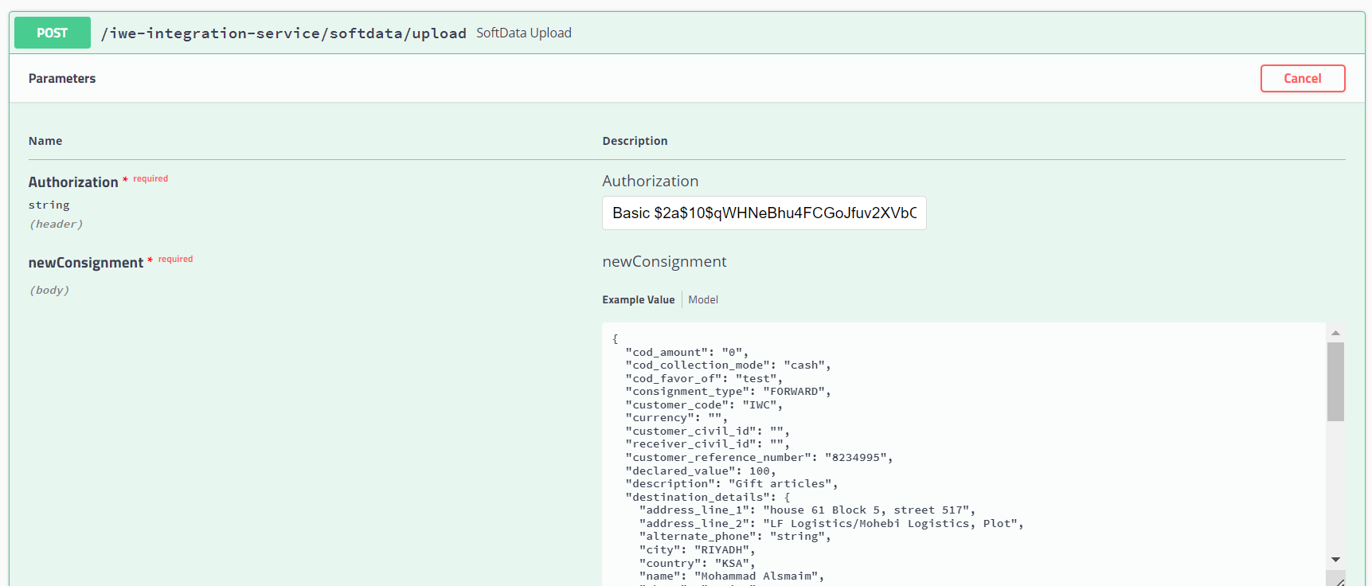Request Payload

Response with <Consignment Reference Number>

#### SAMPLE REQUEST

{

"cod_amount": "100",

"currency": "SAR",

"cod_collection_mode": "cash", "cod_favor_of": "test", "consignment_type": "FORWARD", "customer_code": "GNM", "customer_reference_number": "296163865",

"customer_civil_id": "23333333",

"receiver_civil_id": "466655557",

"declared_value": 100, "description": "Gift", "destination_details": {

"address_line_1": "house 61 Block 5, street 517", "address_line_2": "LF Logistics/Mohebi Logistics, Plot", "alternate_phone": "string",

"city": "Kuwait",

"country": "Kuwait", "name": "الصميم محمد", "phone": "string",

"pincode": "91710",

"state": "string"

},

"dimension_unit": "CM", "height": "5",

"is_risk_surcharge_applicable": true,

"length": "10", "load_type": "DOCUMENT", "notes": "test", "num_pieces": 10, "origin_details": {

"address_line_1": "LF Logistics/Mohebi Logistics, Plot", "address_line_2": "Mohebi Logistics; Plot WT01 & WT04", "alternate_phone": "",

"city": "Dubai",

"country": "UAE", "name": " الكوخ مجموعة",

"phone": "97101606811863",

"pincode": "8005",

"state": "DUBAI"

},

"pieces_detail": [

{

"declared_value": 100, "description": "Gift", "height": 100,

"length": 500,

"weight": 1.2,

"width": 200,

"quantity": "1"

}

],

"service_type_id": "PREMIUM", "weight": 1.2,

"weight_unit": "KG",

"width": "200"

}

**API #2: Shipping Label**

## API URL:

## https://dev-b2b.iwexpress.com:5001/iwexpress/iwe-integration-service/{referenceNumber}/shippingLabel

## Sample Request:

## <https://dev-b2b.iwexpress.com:5001/iwexpress/iwe-integration-service/IW00001/shippingLabel>

## Request Type: GET

### Input Authorization as below.

Basic $2a$10$qWHNeBhu4FCGoJfuv2XVbO9Yq4QBUwGSvNM0bGpYUVc3iY8jXsJwO

Response: <pdf file>

**API #3: Consignment Creation with Shipping Label generation**

API URL: <https://dev-b2b.iwexpress.com:5001/iwexpress/iwe-integration-service/softdata/upload/v2>

Request Type: POST

Input Authorization: Basic $2a$10$qWHNeBhu4FCGoJfuv2XVbO9Yq4QBUwGSvNM0bGpYUVc3iY8jXsJwO

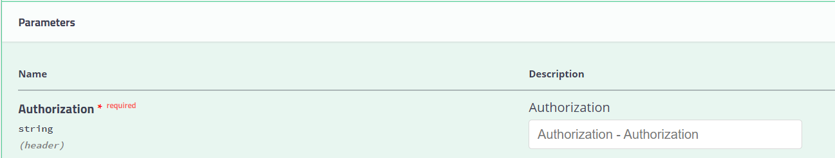

### Order Details as like below structure (JSON Provided)

Request JSON

{

"cod_amount": "string",

"currency": "string",

"cod_collection_mode": "string", "cod_favor_of": "string", "consignment_type": "string", "customer_code": "GNM", "customer_reference_number": " string",

"customer_civil_id": "string",

"receiver_civil_id": "string",

"declared_value": 0, "description": "string", "destination_details": {

"address_line_1": "string", "address_line_2": "string", "alternate_phone": "string", "city": "string",

"country": "string",

"name": "string",

"phone": "string",

"pincode": "string",

"state": "string"

},

"dimension_unit": "string", "height": "string", "is_risk_surcharge_applicable": true, "length": "string",

"load_type": "string", "notes": "string", "num_pieces": 0, "origin_details": {

"address_line_1": "string", "address_line_2": "string", "alternate_phone": "string", "city": "string",

"country": "string",

"name": "string",

"phone": "string",

"pincode": "string",

"state": "string"

},

"pieces_detail": [

{

"declared_value": 0, "description": "string", "height": 0,

"length": 0,

"weight": 0,

"width": 0,

"quantity": "string"

}

],

"service_type_id": "string", "weight": 0,

"weight_unit": "string", "width": "string"

}

#### SAMPLE REQUEST

{

"cod_amount": "100",

"currency": "SAR",

"cod_collection_mode": "cash", "cod_favor_of": "test", "consignment_type": "FORWARD", "customer_code": "GNM", "customer_reference_number": "296163865",

"customer_civil_id": "23333333",

"receiver_civil_id": "466655557",

"declared_value": 100, "description": "Gift", "destination_details": {

"address_line_1": "house 61 Block 5, street 517", "address_line_2": "LF Logistics/Mohebi Logistics, Plot", "alternate_phone": "string",

"city": "Kuwait",

"country": "Kuwait", "name": "الصميم محمد", "phone": "string",

"pincode": "91710",

"state": "string"

},

"dimension_unit": "CM", "height": "5",

"is_risk_surcharge_applicable": true,

"length": "10", "load_type": "DOCUMENT", "notes": "test", "num_pieces": 10, "origin_details": {

"address_line_1": "LF Logistics/Mohebi Logistics, Plot", "address_line_2": "Mohebi Logistics; Plot WT01 & WT04", "alternate_phone": "",

"city": "Dubai",

"country": "UAE", "name": " الكوخ مجموعة",

"phone": "97101606811863",

"pincode": "8005",

"state": "DUBAI"

},

"pieces_detail": [

{

"declared_value": 100, "description": "Gift", "height": 100,

"length": 500,

"weight": 1.2,

"width": 200,

"quantity": "1"

}

],

"service_type_id": "PREMIUM", "weight": 1.2,

"weight_unit": "KG",

"width": "200"

}

Response JSON: [PDF Stream response]

**API #4: Consignment Tracking**

API URL:

[https://dev-b2b.iwexpress.com:5001/iwexpress/iwe-integration-service/tracking/{referenceNumber}/shipment](https://dev-b2b.iwexpress.com:5001/iwexpress/iwe-integration-service/tracking/%7breferenceNumber%7d/shipment)

referenceNumber: [consignment reference number]

Request Type: GET

Authorization: Basic $2a$10$qWHNeBhu4FCGoJfuv2XVbO9Yq4QBUwGSvNM0bGpYUVc3iY8jXsJwO

Sample Request:

<https://dev-b2b.iwexpress.com:5001/iwexpress/iwe-integration-service/tracking/IW00001/shipment>

Response JSON: [Consignment Tracking details]

**Client Status Update Webhook**

**Domestic Shipments**

Following are the list of events (with description) supported which is provided in the key type as seen in the payload. Supported Events

1. **accept** - When the consignment is out for delivery

2. **added_to_bag** - When the consignment is added to a bag in a trip

3. **assigned_for_delivery** - When an consignment is assigned to any rider for delivery

4. **assigned_to_hub** - When task is assigned to rider for delivery

5. **attempted** - When a consignment is undelivered

6. **bag_received** - When bag is unloaded from the trip

7. **cancelled** - When a consignment is cancelled

8. **consignment_verification** - When consignment Verification is done

9. **customs_clearance_completed** - When the consignment is cleared from customs

10. **delay_at_airport** - When the consignment is at airport and not processed due to some reasons

11. **delivered** - When a consignment is delivered

12. **delivery_pod** - When the 3PL send s POD separately post the delivered event (Select this event is you ar using delivered event)

13. **deps_exception** - When the consignment is received as Damaged, Excess, Shortage or Pilferage

14. **exception** - When a event is received that does not belong to other events in the list

15. **handed_in_customs_clearance** - When the consignment is handed to the customs at airport

16. **handover_courier_partner** - When the consignment is handed over to the 3PL

17. **inscan_at_hub** - When a consignment is inscanned at any hub

18. **intransittohub** - When a consignment is part of any mid mile hub and the mid mile trip is ongoing

19. **lost** - When a consignment is lost

20. **not_picked_up** - When the consignment is not picked up

21. **on_hold** - When consignment is put on hold for some reasons

22. **out_for_pickup** - When the delivery executive is out for pickup

23. **out_for_store_pickup** - When the delivery executive is out for pickup (PUDO Flow only)

24. **outscan_at_hub** - When a consignment is marked as outscan from a hub

25. **pickup_awaited** - When the delivery executive is yet to be assigned for pickup

26. **pickup_completed** - When the pickup is completed by the delivery executive

27. **pickup_scheduled** - When the pickup has been scheduled for a consignment

28. **reachedathub** - When the consignment reached the destination hub (generally the last mile hub)

29. **release_on_hold** - When a consignment is released from hold

30. **reschedule** - When the consignment pickup or delivery is rescheduled

31. **returned_at_hub** - When the consignment is received at hub post a delivery attempt

32. **revert_from_delivered** - When a consignment is revoked from delivery for exceptional reasons (Aplicable from CRM)

33. **revoke_rto** - When RTO is revoked for exceptional reasons (Applicable from CRM)

34. **rto** - When the consignment is marked as RTO

35. **rto_attempted** - When the consignment is undelivered in a RTO journey

36. **rto_delivered** - When the consignment is delivered in a RTO journey

37. **rto_in_transit** - When the consignment is in transit in a RTO journey

38. **rto_initiated** - When the consignment is marked as RTO (this is a preferred over the event rto)

39. **rto_inscan_at_hub** - When the consignment is inscanned at hub in a RTO journey

40. **rto_outfordelivery** - When the consignment is out for delivery in a RTO Journey

41. **seized** - When the consignment is seized by an external party before being delivered

42. **shelved** - When the consignment is shelved for some reasons

43. **softdata_upload** - When consignment is created in Shipsy system

44. **vehicle_arrived** - When the vehicle has arrived to a different hub in a middle mile trip

**Cross Border Shipments**

Following are the list of events (with description) supported which is provided in the key type as seen in the payload.

Supported Events

1. on_hold

2. release_on_hold

3. pickup_completed

4. delivered

5. attempted

6. rto

7. cancel

8. shipment_clear_successfully

9. intransit_to_hub

10. reached_at_hub

11. inscan_at_hub

12. accept